Conflicts of Interest Statement

Re: DIB-D-17-00415
Title: Optical properties and impedance spectroscopy analyses for microscale Si pillar solar cells

We declare that this manuscript is original, has not been reported before, and is not currently being considered elsewhere. We also confirm that there is no known conflict of interest regarding this manuscript and its publication. The manuscript has been approved by all named authors.

Sincerely yours,

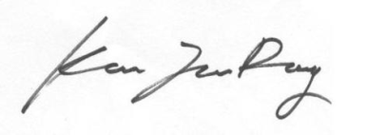
Joondong Kim

Joondong Kim, Ph.D./Professor
Department of Electrical Engineering,
Incheon National University
E-mail: joonkim@ incheon.ac.kr
Phone: +82-32-835-8770; fax: +82-32-835-0773

